User Guide

jWebSocket
SMS Gateway

Mayra Eva Marañón Rodriguez
Version 1.0

Versioning Control
Date | Version | Description | Autor
28/03/2012 | 1.0 | Preparing the document. | Mayra Eva Marañón Rodriguez

1. Characteristics of the solution
The jWebSocket SMS gateway allows sending SMS text messages to mobile phones (SMS) through the WebSocket protocol, which provides high speed and real-time work. The application is developed with the jWebSocket framework.
The SMS gateway can be embbedded into standalone applications, to enrich their functionality or for the purpose to send SMS messages from a web page. It is a gateway that has captcha mechanism, this is a challenge-response test used to determine whether the user is human or not. This functionality is used to prevent robots, also called spambots, to use the SMS service provided by the SMS gateway.

- Main functionalities
- SMS Gateway with a anti-spam captcha mechanism as validation method which is a challenge-response test used to determine when the user is human or not.
- Send SMS (Short Message Service) functionality is composed by the message, number of the mobile and the ID of the person receiver.
- Send bulk SMS allows sending a message by passing a list of target phone numbers, and optionally the sender phone number of the person who sends the message.
- Send longer SMS: If the SMS contains more than 160 characters it will be sent as a longer message. In longer SMS, known as Concatenated SMS, the longer text is automatically divided up and sent in several parts. The receiver then combines the parts of the interrelated text again in the terminal device.
- Receiving status messages sent by the provider to for obtain a success/error notification of the send operation.

The SMS Gateway is an SMS service that offers the possibility of integration of any client software with the gateway for sending SMS messages in a simple and fast way. Sending SMS from the web is used in applications for reports fast in sending data of bank statements, notices of sport, weather, news, horoscopes among many other applications that may use of this service, with the use of SMSGateway the clients can receive the reports when they are not online in the internet.
3. Problems to be solved
Problem | Contributions of the solution
The jWebSocket framework does not count with a communications medium for it use in sending SMS through the WebSocket protocol. | SMSGateway allow:  - Sends SMS messages from a WebSocket connection.  - Ensure delivery and the collection of data for interaction with applications.  - Provides a powerful and versatile communication. Provides a direct channel to anyone who owns a cell phone.  - Have Speed of delivery and provides international coverage.  SMSGateway count with a captcha sistem that allow:  - It delivers a high speed to create the catpcha image using a WebSocket connection.  - Prevents automated software for performing actions that degrade the quality of services.  - Protect vulnerable systems of spam.  - Used to limit and control human access to certain systems.

4. Glossary
Short Message Service (SMS): is a text messaging service component of phone, web, or mobile communication systems, using standardized communications protocols that allow the exchange of short text messages between fixed line or mobile phone devices.
SMS text messaging is the most widely used data application in the world, with over 3.7 billion active users, or 74% of all mobile phone subscribers. The term SMS is used as a synonym for all types of short text messaging as well as the user activity itself in many parts of the world. SMS is also being used as a form of direct marketing known as SMS marketing.
SMS as used on modern handsets originated from radio telegraphy in radio memo pagers using standardized phone protocols and later defined as part of the Global System for Mobile Communications (GSM) series of standards in 1985 as a means of sending messages of up to 160 characters, to and from GSM mobile handsets. Most SMS messages are mobile-to-mobile text messages though the standard supports other types of broadcast messaging as well.
Captcha: is a type of challenge-response test used in computing as an attempt to ensure that the response is generated by a person. The process usually involves a computer asking a user to complete a simple test which the computer is able to grade. These tests are designed to be easy for a computer to generate, but difficult for a computer to solve, so that if a correct solution is received, it can be presumed to have been entered by a human. A common type of CAPTCHA requires the user to type letters or digits from a distorted image that appears on the screen, and such tests are commonly used to prevent unwanted internet bots from accessing websites.

Model of the solution
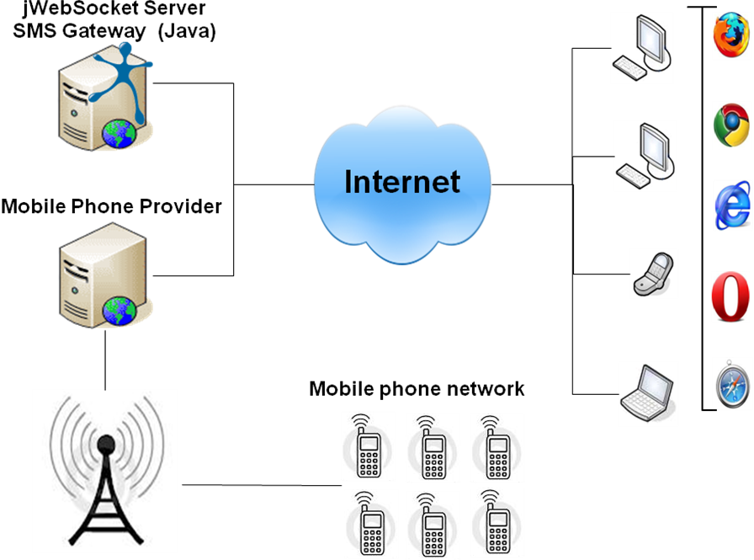
To access the SMS gateway application the user requires a browser that supports WebSocket protocol or a flash plug-in for a fallback mechanism as well as a long/polling comet fallback, which allows also users of older browsers and users of proxies use the solution. First you must authenticate to the application then meet the challenge of captcha and ultimately send the SMS you want. The jWebSocket server which is installed on your PC communicates with the mobile phone provider which sends SMS to the mobile phone network. Multiple providers are supported.
7. Requirements for Use
To use the SMS gateway you must have Internet access and use any of the browsers that support the communication protocol WebSocket. See comment above. Some of them are Google Chrome 4, Safari 5, Mozilla Firefox 8, Opera 11 and Internet Explorer 10.

9. System Operation
Initial view and main application: Allows users with permission to authenticate against the application so he can interact with the application, meet the challenge of captcha and send the SMS he wants.
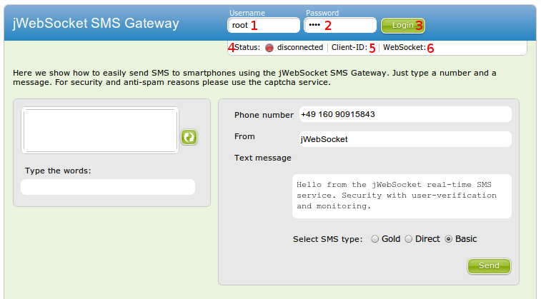

1-> Field to insert the username to authenticate to the application.
2-> Field to insert the password.
3-> To access the application. Establish the connection to the server.
4-> Displays the status of the application (Authenticated / Offline).
5-> Displays the id of the websocket connection.
6-> Displays the connection information (native/flash/comet).
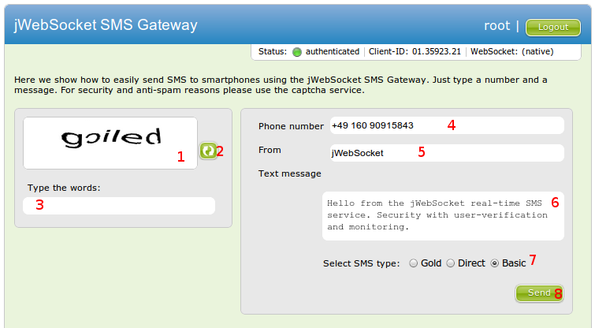

1-> Image with challenge-response captcha image.
2-> Button to generate a new challenge-response of different captcha image, in case the current one can not be identified clearly.
3-> Input field for the key word of challenge-response captcha image.
4-> Field to enter the number or list of numbers to which the user wants to send the SMS.
5-> Input field for the id of the user sending the SMS.
6-> Input field for the SMS message text, if the user types more than 160 characters here automatically splitting it into multipart messages.
7-> Select type of SMS sent.
Basic SMS: Send affordable and reliable text messages to Germany. Please note that we have no control over what companies decide to carry SMS.
Gold SMS: Send text messages worldwide using all features. You can define the sender's number yourself.
Direct SMS: Use full-featured worldwide text messaging directly through the network carriers.
8-> Button that allows the verification of the keyword and also sending the SMS.

9. Configurations of the solution
This application is not required configurations and customizations.

10. Rules of the solution
R1: If the user mistype your username or password, during access to the application, the system issues an error message and does not continue with the normal flow. Solution: The user must repeat your username and password again.
R2: If the user mistype the keyword of the challenge-response captcha image the system issues an error message and does not continue with the normal flow. Solution: The user must repeat again the challenge-response captcha image and then correspondingly this will send the SMS message.

R3: If the SMS contains more than 160 characters it will be sent as a longer message. In longer SMS, known as Concatenated SMS, the longer text is automatically divided up and sent in several parts. The receiver then combines the parts of the interrelated text again in the terminal device.
R4: If the SMS contains invalid characters in the phone number the SMSGateway throw a exeption for request to the user enter the phone number in the correctly way.
R4: If the provider cannot be accessed, the administrator need check the account in SMSTrade.

